Rio de Janeiro and London Homework – Pentecost Term 2025
English  Learn a London poem off by heart and perform it to the class | English  Choose a capital city from around the world. What can you find out about it? How does it compare to London? |  | History  Write a newspaper article about a significant event in the history of London – The Great Fire, The Blitz or any other event that you choose. |  | Maths  How can you travel from London to Rio de Janeiro? Which way is the shortest distance? Which is the longest? What is the difference between the distances? What would the distance be in km and miles?
Geography  Create an aerial map of either London or Rio de Janeiro.  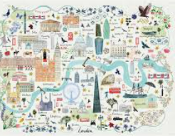 | Science  Think about animals in Rio de Janeiro and create a food chain.  MFL  What language is spoken in Rio de Janeiro? Learn a few phrases. |  | Art  Design a new landmark for either London or Rio de Janeiro  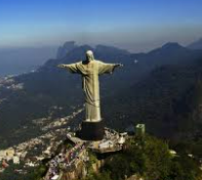 |  | Art/Design and Technology  Create or sketch one of the famous landmarks in either Rio de Janeiro or London.  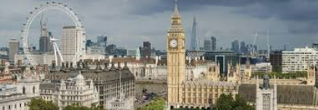
Design and Technology  Think about the traditional foods that are eaten in each country. Write a recipe for one of these foods. Is it a healthy recipe? You could even follow the recipe to make your chosen food item. |  | ?  Free choice |  | PSHE/Thinking Skills  Where would you rather live: Rio de Janeiro or London? Why?  