**KS1 attainment information 2023 – 24**

**KS1 2023/24: No progress measures**

It will not be possible to calculate KS1-KS2 progress measures for academic years 2023/24 and 2024/25. This is because there is no KS1 baseline available to calculate primary progress measures for these years due to Covid-19 disruption.

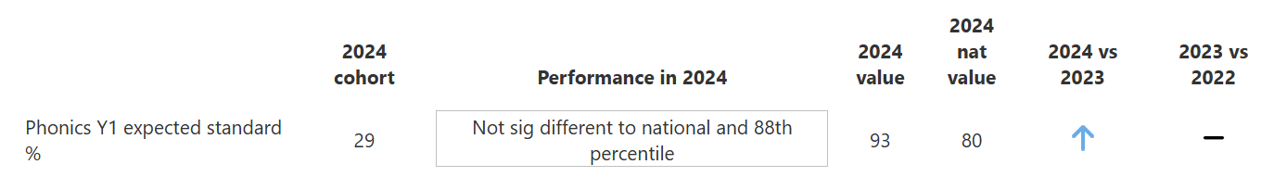**KS1 phonics score 2023 – 2024**

**KS1 Assessments 2023 – 24**

**Maths Attainment:**

| **Cohort** | **Achieving the Expected Standard (%)** | **Achieving a Higher Standard (%)** |
| --- | --- | --- |
| **All Pupils** | 70% | 3% |

**Reading Attainment:**

| **Cohort** | **Achieving the Expected Standard (%)** | **Achieving a Higher Standard (%)** |
| --- | --- | --- |
| **All Pupils** | 67% | 13% |

**Writing Attainment:**

| **Cohort** | **Achieving the Expected Standard (%)** | **Achieving a Higher Standard (%)** |
| --- | --- | --- |
| **All Pupils** | 57% | 4% |

**Reading, Writing and Maths combined:**

| **Cohort** | **Achieving the Expected Standard (%)** | **Achieving a Higher Standard (%)** |
| --- | --- | --- |
| **All Pupils** | 53% | 3% |