Writing  Angry Earth – Homework Lent 2 Term 2025  Create a leaflet explaining what Volcanoes, Earthquakes and Tsunamis are. Don’t forget to use: · Headings & subheadings · Images & captions · Key facts & opinions · Examples of famous volcanic eruptions | Thinking Skills    Create an A-Z on all things Angry Earth. Include things, places, words that links to the topic. | Maths  Go around you house and measure different items. Make sure you are measuring in millimeters, centimeters and meters! Can you convert any of your measurements into different units?
Art  Create an abstract piece of art representing something that makes the Earth angry, e.g. tsunamis, volcanoes and earthquakes. | You only need to complete one box a week! I have given you more activities than there are weeks so please do not feel like you have to complete the whole table. | Research    What is used to measure earthquakes?
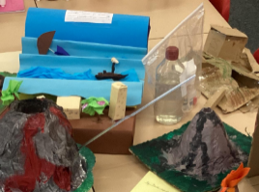  Design and Technology  Design or create your very own natural disaster. |  | Book worm  Find a book about anything Angry Earth. Curl up with a family member (or alone) and enjoy the book.
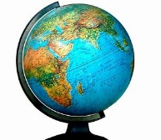  Geography  Where and what is the Ring of Fire? Why is it important?  How could you represent this creatively? | Science  Think about going out on a sunny day, create an information poster telling people+ how to stay safe in the sun. Make sure it is eye catching, encouraging the reader to read it. | Computing  Make a PowerPoint on the Volcanoes/ Earthquakes/ both. It should outline what causes them and give examples of famous disasters and what happened.

