Book worm  Tremors – Homework Lent 1 Term 2025  Find a book that is set in Ancient Rome. Curl up with a family member (or alone) and enjoy the book. | Thinking Skills    Create an A-Z on all things Ancient Rome. Include things, places, words that links to the country. | Maths  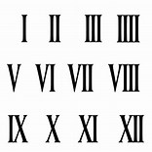  What are Roman Numerals?  Can you create a poster to present to the a class.
Design and Technology    Design and create your own volcanoes! Can you make it erupt? | You only need to complete one box a week! I have given you more activities than there are weeks so please do not feel like you have to complete the whole table. | Creative Writing  Create a mind map of different adjectives that could describe the eruption of Mount Vesuvius
Research  Do some research on the Ancient Roman Gods and Goddesses. Who were they? Why did they worship them? |  | 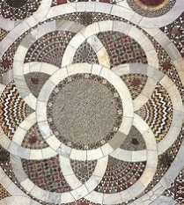  Art  Design a mosaic floor that you might find in a grand home in Pompeii.
  Geography  Where is Mount Vesuvius?  Can you locate it on a map.  How could you represent this creatively? | Science  Have a look at the soil in your garden? What is it made of?  Make a list of what your find! | Get Active  Imagine you are an Ancient Roman child without modern day technology, look around in your garden, what games could you play? Think about how Tranio played knucklebones.

