Sacred Heart Primary CVA

Southcliffe Road, Carlton, Nottingham. NG4 1EQ

[admin@sacredheart.notts.sch.uk](mailto:admin@sacredheart.notts.sch.uk) 0115 9112117

https://www.sacredheart.notts.sch.uk/



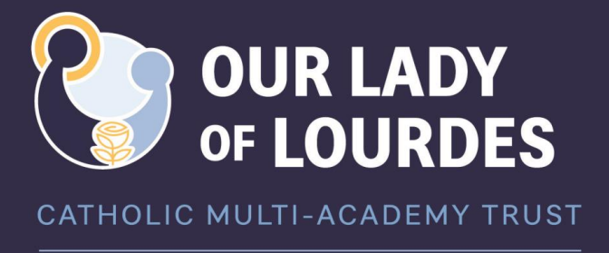

**8th January 2025**

Dear parents/carers,

Year 6 will be starting their booster classes on **Thursday 23rd January**. The purpose of these sessions is for the children to have the opportunity to practise test technique and familiarise themselves with the test formats, as well as revise previously taught content, in preparation for the SATs in May. In previous years, booster sessions have always proved very successful in building the children’s confidence and helping them to feel fully prepared for the tests. The children will be split into small groups according to ability to enable them to focus on the key skills they need practise and develop. Homework will be sent home after each session which will need completing and returning to school by the following Thursday.

The sessions will take place **after school on a Thursday** until 4:30pm and will run up until the Easter holidays. Children will need collecting from the playground gate at 4:30pm. Children who have permission to walk home from school will be allowed to go by themselves if you are happy for them to walk home at this later time.

If you child will be unable to attend booster sessions do to a clash with out of school activities, please let me know and I will arrange for the booster papers to be sent home with your child at the end of the day each Thursday.

If you have any questions, please let me know.

Kind regards,

Miss Armstrong