Travel  What makes Britain Great? Homework – Advent 2 Term 2024  Create a fact file of any city in Great Britain, think about what important information you should include, that might be the population, famous people, inventions. | Thinking Skills    Create an A-Z on all things Great Britain. Include things, places, words that links to the country. | Maths  Practice your 3, 6, 4 and 8 timetables.  Imagine you are trying to teach the year 2’s these timetables; how could you present them in an interesting way to help them?
Design and Technology  Imagine you are going to a street party, bake or make something to contribute. This could be a cake, bunting, plate design, or a sandwich recipe etc. | You only need to complete one box a week! I have given you more activities than there are weeks so please do not feel like you have to complete the whole table. | Creative Writing  Write a story of a journey to a different part of the country, like Dick Whittington’s journey to London.
  Research  What is Nottingham on the map for? Create a poster, presentation or fact file showing what Nottingham has contributed to Great Britain, these may be inventions, recipes, sports or famous people. |  | Art  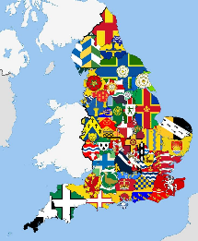  All counties in the UK have a different flag, design a new flag for Nottinghamshire. What do you think is important to include on the flag?
Geography  Create a map of England labelling as many counties as possible. | Science  Think about your daily life, what forces do you use?  Keep a bullet point diary over the week writing down any time you have noticed a force being use (push, pull and twist). | Get Active  Go for a walk, think about how the city is connected to the rest of the country, what do you see that tells us this, road signs to motorways, rivers, airports etc.

