 Sacred Heart Primary CVA 



Our Maths Policy

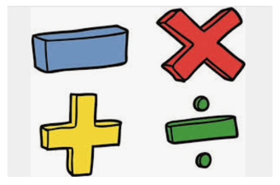

The science and study of number, structure, space, and change. Mathematicians seek out patterns, formulate new ideas, and establish truth using a systematic approach.

A person who understands math is able to understand basic life skills such as managing a budget, building furniture, forecasting, and telling time. Math helps you understand costs, balance a bank account, and subtract balances which are essential skills as adults.

.

The Patron Saint of Maths is:

Saint Hubert

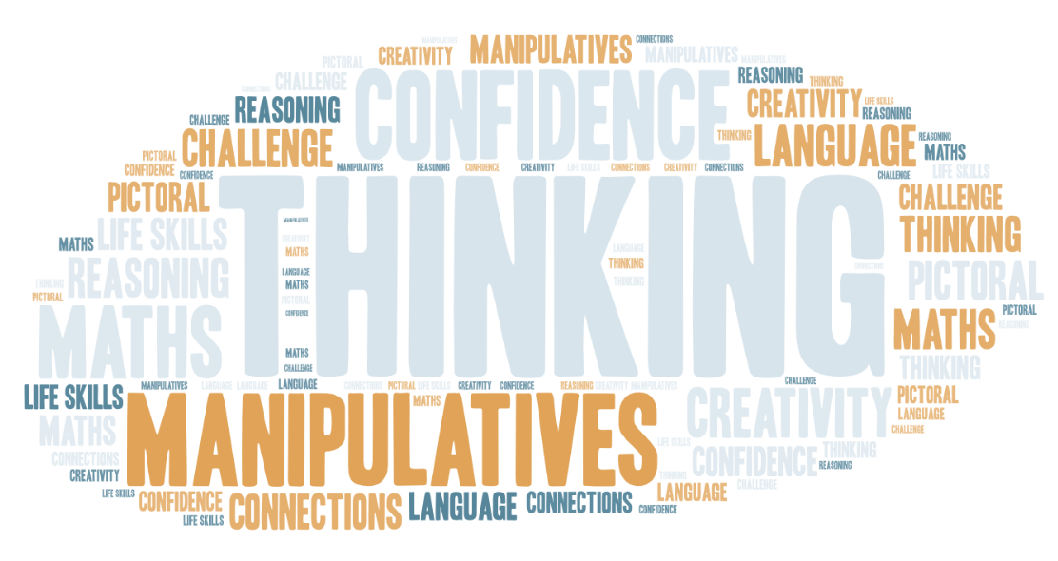



Intent

Sacred Heart CVA intends to use the White Rose scheme of work for progression and a range of resources from White Rose, TTRS, NCETM, NRICH, Primary Stars and other online sources to ensure we offer a relevant, broad, vibrant and ambitious maths curriculum that will inspire and excite our pupils. We want our children to enjoy learning maths, which comes through a growing belief in their own ability to achieve successfully within the challenges they undertake. In maths, we believe this is achieved when children are confidently fluent in their understanding of number and in their calculation skills. With this confidence, they can apply what they know to reason and explain their thinking and to solve problems, developing mastery and accessing higher levels of understanding. Using our carefully sequenced delivery of the maths curriculum, we want our children to be ready to progress to the next stage of their learning, believing in their own ability to be successful mathematicians. Key knowledge and skills are also revisited regularly allowing repetition to embed learning. A concrete, pictorial, abstract approach provides children with a clear structure in which they can develop their depth of understanding of mathematical concepts. We aim to ensure that mathematics is a high-profile subject, which children view positively and with a ‘Can do’ attitude.

All pupils will be expected to achieve their full potential by encouraging high expectations and excellent standards in their maths learning - the ultimate aim being that pupils will view maths as absorbing, creative and valuable – with a passion to explore the world of number and an understanding of how maths is used in everyday life. Through problem solving and investigation, we want them to develop resilience, perseverance and independence.

The intent is that all content will be continuously updated and reviewed annually, creating a dynamic programme of study that will be clearly outlined in both long-term and short-term planning. This will ensure that the maths knowledge of our pupils progresses within each academic year and is extended year upon year throughout the primary phase and, in so doing, will always be relevant and in line with meeting or exceeding national DfE requirements.

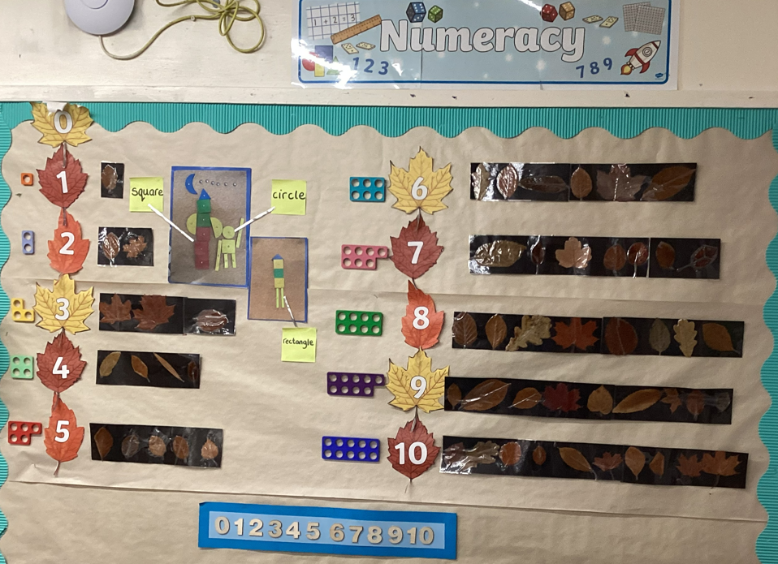

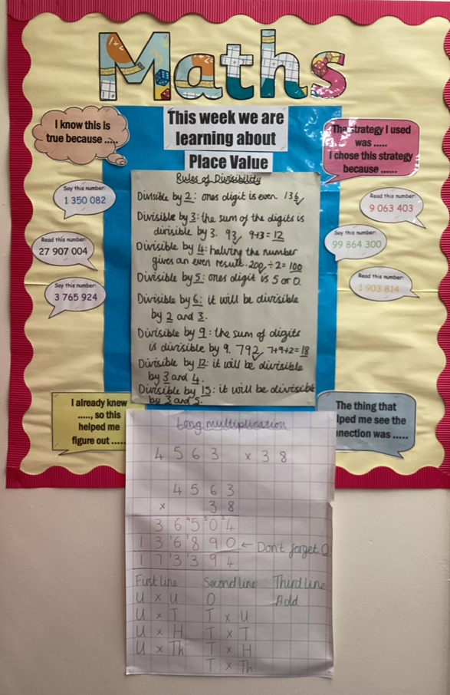

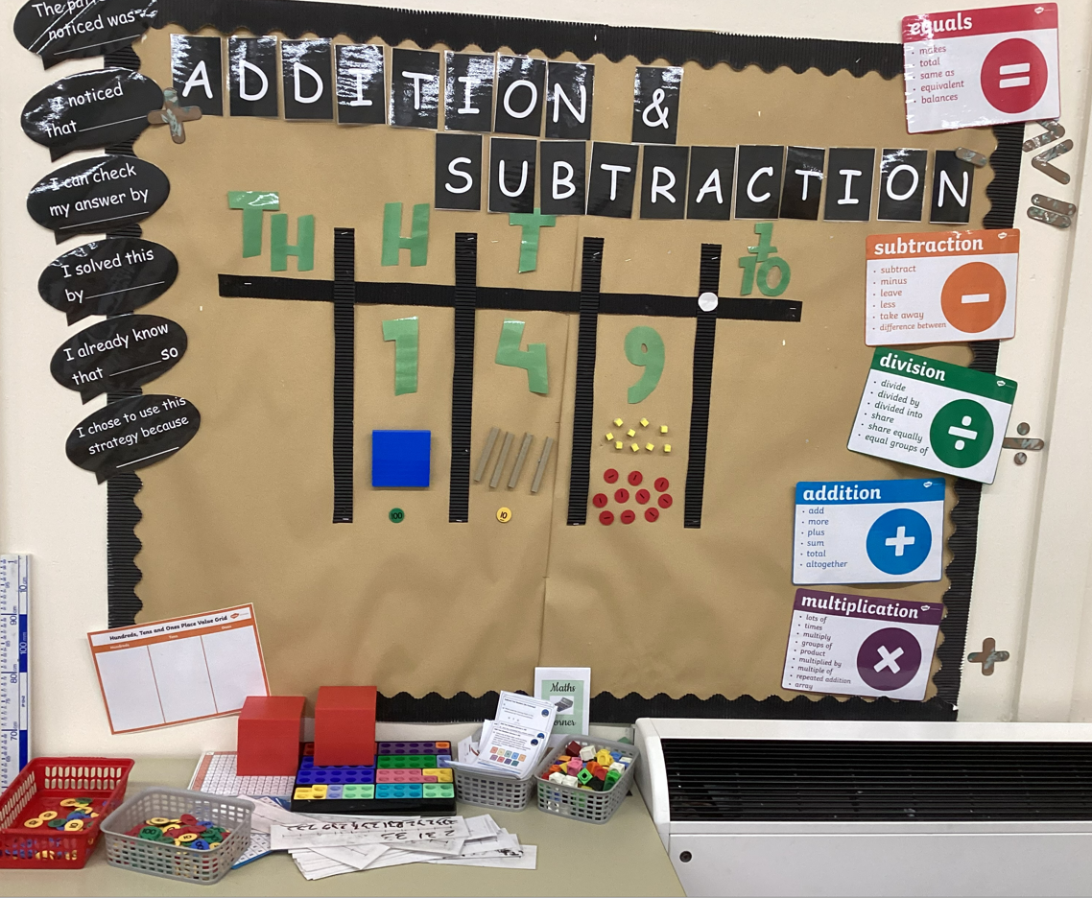

Implementation

[Link to the 2014 National Curriculum](https://assets.publishing.service.gov.uk/government/uploads/system/uploads/attachment_data/file/335158/PRIMARY_national_curriculum_-_Mathematics_220714.pdf)

At Sacred Heart Catholic Voluntary Academy, teachers plan maths lessons following the National Curriculum and new White Rose scheme of work. Maths is taught daily as a discrete lesson, which is enhanced by regular Times Tables and Mental Maths sessions outside of the maths lesson. An explicit problem-solving lesson is also taught fortnightly. The use and secure understanding of maths knowledge and skills are also threaded through other areas of the curriculum in order to provide relevant opportunities to use and apply. Children learn using a range of resources, which support a concrete, pictorial and abstract approach guiding them through their understanding of mathematical processes. Our Calculation Policy is used consistently across the school and provides sequential building of knowledge and skills in using and applying the four operations. Correct mathematical vocabulary is used by all teachers and this is discussed with and explained to children who are then encouraged to use it independently when talking about maths. Children’s progress in maths is carefully tracked through a range of assessment strategies to ensure teachers identify where children require support or challenge to assist their progress. Timely intervention is provided by the class teacher or support staff to address any misconceptions or gaps in understanding to enable children to confidently progress towards their next lesson.

All mathematicians are challenged to show their mastery of maths concepts through investigations and problem-solving tasks for every objective. We predominantly use the White Rose scheme of work to encourage understanding of concrete and pictorial problems solving methods which further support the abstract understanding. Resources, such as Numicon, base 10 and number frames are carefully selected to enable understanding within maths and as a tool for intervention work.

Achievement is celebrated at all stages through school wide presentations and displays. Children are motivated by the opportunity for recognition both in school and at home for successes along their maths learning journey. By engaging children in whole school challenges, we maintain a high profile for the teaching and learning of maths. Through cross-curricular practical activities we make maths relevant to children’s lived experiences.

Every lesson of maths at Sacred Heart starts with retrieval practice, the pupils practice skills that have been previously learnt from last year, last month, last week and last lesson. Maths skills practised outside the lessons are carefully selected to look at fluency and a range of operations within a short session to enable the pupils to ‘jump’ between knowledge of operations and concepts.

Staff CDP

All staff receive quality CPD through a Local Authority Advisor on the use of manipulatives in the maths lesson as well as access to White Rose jigsaw CPD recorded sessions. The staff also learn from their colleagues through cross Trust moderation and network meeting.

Monitoring

The mathematics leader and senior management are responsible for observing practice and monitoring the quality and impact of mathematics teaching and learning.

Monitoring throughout the school takes place whereby the subject leader:

* Updates the staff expectations document for mathematics ensuring it is clear and concise.
* Planning – checking for coverage of knowledge, supports teachers via discussion of our whole- school progression map to adapt and make changes if necessary.
* Book audits and Pupil voice.
* Reviews resource provision.
* Discusses regularly with the Headteacher, the progress implementing this policy within school.
* Learning walks, which involve lesson observation drop ins.
* Curriculum link governor will also visit to see ‘Our Curriculum’ in action.

# Assessment and Reporting

**Teacher assessment –** This is ongoing in lessons and on the completion of a unit of learning, using pre and post assessments to aid teacher assessment for KS1 and 2. Throughout school, questioning, observation of work and approaches used, pupils’ responses to their own and each other’s work, and final outcomes evidenced in books/saved work all inform the assessment process. Pupils complete NFER assessments in the Advent and Pentecost Terms.

**Self and peer assessment** – Opportunities for this are used during lessons, involving positive and constructive critique of their own work, and that of others.

**Reporting to parents –** Comments regarding progression against the age-related expectations for this subject are reported to parents as part of the end of year report.

**Reporting to governors –** The subject lead and mathematics link governor meet annually to review progress in the subject and to discuss key priorities for the upcoming year. A written report is submitted to governors, reporting progress and attainment in all year groups and national results in Years 2,4 and 6.

Ideas to develop further interest in Mathematics at home:

Keep a running total of the cost of items in a shop.

Work out change in a shop or how much a discount will be.

<https://www.topmarks.co.uk/Search.aspx?Subject=16>

<https://ttrockstars.com/>

<https://login.mathletics.com>

<https://home.oxfordowl.co.uk/kids-activities/fun-maths-games-and-activities/>

<https://www.bbc.co.uk/bitesize/subjects/zjxhfg8>

<https://www.bbc.co.uk/bitesize/subjects/z826n39>

I like how we get to talk about our maths.

Maths is fun and I like challenging myself in problem solving

Development Actions for 23-24

**1**: Develop a consistent lesson structure across all year groups to enhance clarity and progression enabling all pupils to reason and problem solve every lesson.

**2:** Raise overall attainment in mathematics across all year groups by the end of the academic year.

**3:** Maths lead has greater knowledge and a stronger grasp on maths across the school including EYFS

Impact

The impact of our mathematics curriculum is that:

* Children understand the relevance and importance of what they are learning in relation to real world concepts
* Children know that maths is a vital life skill that they will rely on in many areas of their daily life
* Children have a positive view of maths due to learning in an environment where maths is promoted as being an exciting and enjoyable subject in which they can investigate and ask questions; they know that it is OK to be ‘wrong’ and that this can strengthen their learning because the journey to finding an answer is most important.
* Children are confident to ‘have a go’ and choose the equipment they need to help them to learn along with the strategies they think are best suited to each problem.

# Our maths books evidence work of a high standard of which children clearly take pride; the range of activities demonstrate good coverage of fluency, reasoning and problem solving. Our feedback and interventions support children to strive to be the best mathematicians they can be, to ensure a high proportion of children are on track or above. Our school standards are high, we moderate our books both internally and externally and children are making progress.

Policy written: November 2024 Written by: J Owens Review: November 2025