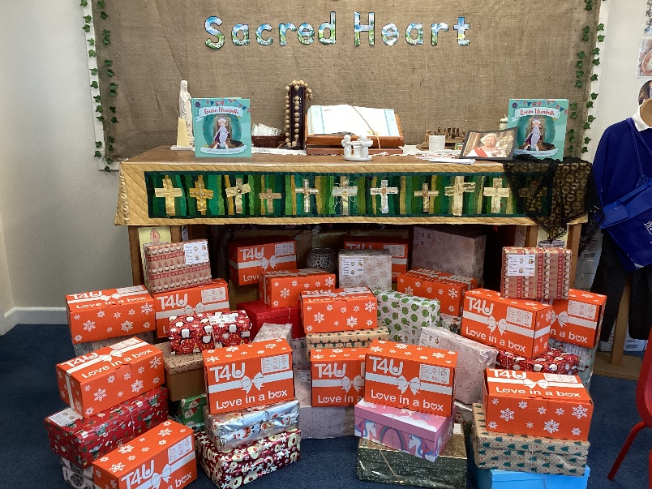

Sacred Heart T4U Shoe Box appeal 2024

Dear Parents,

Sacred Heart would like to once again support the T4U shoebox appeal this year. Each year, T4U run a nationwide appeal to provide Christmas gifts to vulnerable children and families. Like in 2023, this year the shoeboxes will be heading to Ukraine, Moldova, Georgia, Bosnia and Romania. T4U work with in country partners like the Red Cross to help us find children that are most in need.

You wrap a lidded shoe box in Christmas paper; wrap the lid separately to the bottom as the contents have to be checked before transportation. Decide on the age you want to buy for (3-5, 6-11, 12+) and if you want to make your shoebox for a boy or girl. Alternatively, the flatpack T4U shoeboxes cost 50p from T4U website. Write a Christmas card and/ or a photo of your family if you would like to, as it adds a personal touch. Fill the box with toys, pens, small colouring book, warm hat, scarf and gloves, pants, toothbrush and tooth paste, shower gel, sweets but **not chocolate as it is perishable**. Complete a T4U label which identifies if the box is for a boy or girl and the age range and glue onto the front of your box. **T4U ask for a suggested donation of £3 towards transportation costs**

There are specific videos on how to wrap and fill your shoebox on the T4U website; [**https://teams4u.com/shoebox-resources/**](https://teams4u.com/shoebox-resources/)**.**

We know it might not be possible for everyone to donate a full box but if you can, donating a few items can make a big difference in our donation. Recipients of the shoebox appeal have been overwhelmed by our school’s generosity. **For some displaced children, it is the only gift they have ever received.** When our own families receive so much, it means so much for these children to receive their shoebox gift too.

Donations of completed Christmas shoeboxes/items to fill a shoebox can be placed in school foyer from Monday 14th October with a final date of Friday 8th November for donations to allow for any packing of individual items into shoeboxes for T4U to collect from school. It is a huge logistical operation for T4U to then check and begin to despatch shoeboxes to those children most in need in Ukraine, Moldova, Georgia, Bosnia and Romania.

Thank you so much for your support.

Kind regards,

Mrs Lucas