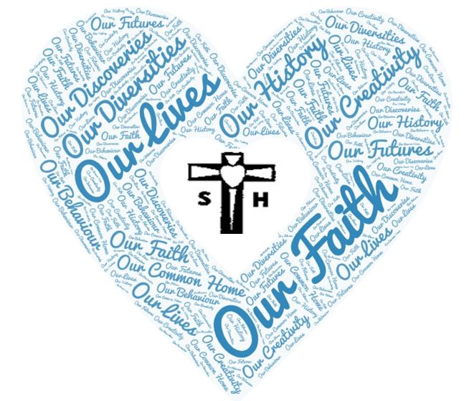



Our Learning – Year 6

2024-2025

|  |  |  |  |
| --- | --- | --- | --- |
| Themes | Our Faith  Our Lives  Our Diversities  Our Histories  Our Discoveries  Our Creativity  Our Common Home | | |
| Year 1 | Advent | Lent | Pentecost |
| Our Religious Education | Creation and Covenant  Prophecy and Promise | Galilee to Jerusalem  Desert to Garden | Dialogue and Encounter  To the Ends of the Earth |
| Our English | Street Child  Story set in the Victorian Era  Biographies  The Explorer  Adventure story  Non-chronological report | Letters from the Lighthouse  Letter writing  WW2 poetry  Journey to Jo’burg  Instructions  Persuasive speech | Holes  Suspense story  Discursive writing  The Song of the Dolphin Boy  Newspaper reports |
| Our Maths | Place Value  Addition and Subtraction  Fractions  Converting time | Decimals  Fractions, decimals and percentages  Converting units of measurement  Fractions, decimals and percentages  Area, perimeter volume  Volume | Shape  Position and direction  Real World maths projects |
| Our Science | Living things and their habitats  The circulatory system | Evolution and inheritance  Light | Electricity |
| Our History | Victorians – Rich and Poor | A Child’s War WWII The impact of the war on the lives of children | Crime & Punishment |
| Our Geography | The Amazon Rainforest | Developing Countries in Africa | Care for Our Common Home |
| Our Computing | Computing systems and networks Communication  Creating Media – 3D Modelling | Creating Media – Web page creation  Data and Information –  Spreadsheets | Programming A –  Variables in games  Programming B –  Sensing |
| Our PE | Val Sabin Dance  Val Sabin games (O)  Netball Basket ball  Gymnastics Unit X  Working together – matching, mirroring and contrasting        Gymnastics Unit Z  Working together – holes and barriers | Games Unit 4  Invasion games  Basketball and tag rugby      Gymnastics Unit Alpha  Counter balance and counter tension  Games Unit 2  Net and wall games  Volleyball and tennis        Gymnastics Unit Y  Working together – synchronisation and cannon | Games Unit 3  Striking and fielding  Cricket and rounders        Athletics Unit 2  Upsweep and downsweep for relay takeover, scissor jump, javelin  Athletics Unit 1  Drive and speed, shot, discus, long jump, triple jump, hurdles    Swimming |
| Our Music | Ostinato  Scales | Trailblazers  Samba Music | Hip-hop/Folk  Transition project Plan |
| Our RSHE | Calm the Storm and DART  DART  Protected Characteristics  Anti- Bullying | Module 1 unit 2  Gifts and talents  Girls Bodies  Boys Bodies    Spots and sleep  Module 1  Unit 3 and 4  Body Image  Peculiar Feelings  Emotional changes  Seeing Stuff Online  Making babies part 1 | Money Matters*  First Aid**  Module 1 Unit 2  Session 1- 4  Module 3 Unit 1  The Trinity  Catholic Social Teaching |
| Our French | A l’Ecole  Le Weekend | La Guerre mondiale  Phonics lesson 4  Les verbs reguliers | Les verbs irreguliers  Boucle d’or et les trois ours |
| Our Art | Drawing: Portraits |  | Drawing: observational and abstract drawing |
| Our DT | Structures: Bridge Across the River  (Geog-Amazon Rainforest) | Sculpture & 3D:  Drawing to Sculpture Henry Moore   (Hist- WW II)  Food: Come Dine with me  Produce from African Countries to make an around the continent meal | Electrical Systems:  Escape Route Game-Prison Alarm System |
| Our Spellings | ay  ee  s  f  sh  j  er |  |  |
| Our Grammar | Nouns and expanded noun phrases  Synonyms and antonyms  Apostrophes for possession  Apostrophes for contraction  Semi-colons, colons and dashes  Clauses | Formal and informal language  The subjunctive  Passive and active voice  Hyphens  Subheadings and bullet points | Revision of KS2 SPaG |
| Our Enhancements | DART  Briars Residential  Holocaust day | WW2 trip | Justice museum |