Year 4 homework- Advent Term 2024
Art  Paint a picture of a Mayan God.  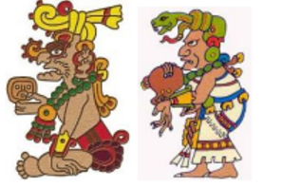 | Use your imagination    Imagine you have a time machine, what questions would you like to ask a Mayan? | Cooking    The Mayans discovered chocolate, make something with chocolate in it.
Get active  Take part in some form of physical activity 3 times per week. Keep a record of the exercise carried out and describe how you felt after you exercised. | Science  Write a 3-day food diary. Organise the foods you have eaten into the correct food groups. | Maths  Play Times Tables rock stars 4 times per week.
Research Skills    Who was the most famous Mayan king or queen? Describe them. | Speaking and listening.  Watch 4 or more of the following vidoes and tell a friend or family member what you have learnt.  https://www.bbc.co.uk/bitesize/topics/zq6svcw | Art  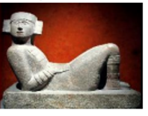  Sketch a Mayan artefact.
RE  Read 2 Bible stories and discuss the meaning of the story with a family member. | Spellings  Practice spellings each week ready for the spelling test on Friday. | Maths  Mathletics once per week.

