 Sacred Heart Primary CVA 



Our Modern Foreign Language Policy



All languages, aside from English, which are spoken and used in different countries around the world. The term 'Modern Languages' is used to distinguish between the languages spoken today and 'Classical languages'.

Research shows that learning a second language boosts problem-solving, critical-thinking, and listening skills, in addition to improving memory, concentration, and the ability to multitask. Children proficient in other languages also show signs of enhanced creativity and mental flexibility.

The Patron Saint of history is:

Saint Jerome

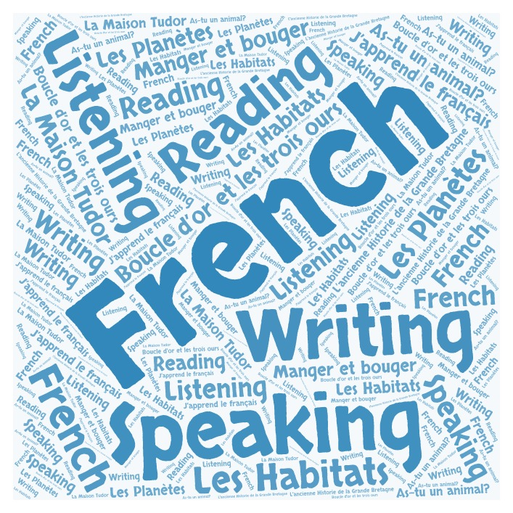



Our Intent

Sacred Heart CVA intends to use the Language Angels scheme of work, with supplementary resources to ensure we offer a relevant, broad, progressive, vibrant and ambitious foreign languages curriculum that will inspire and excite our pupils using a wide variety of topics and themes interleaved to complement other areas of our curriculum. All pupils will be expected to achieve their full potential by encouraging high expectations and excellent standards in their foreign language learning - the ultimate aim being that pupils will feel willing and able to continue studying languages beyond Key Stage 2.

Our intent is that all pupils will develop a genuine interest and positive curiosity about foreign languages, finding them enjoyable and stimulating. Our Curriculum has been developed to ensure that our pupils know and remember more using their new language knowledge in purposeful ways. Learning a second language will also offer pupils the opportunity to explore relationships between language and identity, develop a deeper understanding of other cultures and the world around them with a better awareness of self, others and cultural differences. The intention is that they will be working towards becoming life-long language learners.

The four key language learning skills; listening, speaking, reading and writing will be taught and all necessary grammar will be covered in an age-appropriate way across Key Stage 2. This will enable pupils to use and apply their learning in a variety of contexts, laying down solid foundations for future language learning and also helping the children improve overall attainment in other subject areas. In addition, the pupils will be taught how to look up and research language they are unsure of and they will have a bank of reference materials to help them with their spoken and written tasks going forward.

​

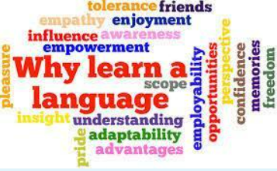

.

[Link to the 2014 National Curriculum for MFL](https://assets.publishing.service.gov.uk/government/uploads/system/uploads/attachment_data/file/239042/PRIMARY_national_curriculum_-_Languages.pdf)

Implementation

Within the Language Angel Scheme and how we have organised Our Curriculum, there are two levels of instruction.

Early Language units are entry level units and are most appropriate for Year 3 pupils or pupils with little or no previous foreign language learning. Intermediate units increase the level of challenge by increasing the amount and complexity (including foreign language grammar concepts) of the foreign language presented to pupils. Intermediate units are suitable for Year 4-5 pupils or pupils with embedded basic knowledge of the foreign language. Progressive and Creative Curriculum units are the most challenging units and are suitable for Year 6 pupils or pupils with a good understanding of the basics of the language they are learning. Grouping units into these Teaching Type categories ensures that the language taught is appropriate to the level of the class and introduced when the pupils are ready.

Pupils will be taught how to listen and read longer pieces of text gradually in the foreign language and they will have ample opportunities to speak, listen to, read and write the language being taught with and without scaffolds, frames and varying levels of support.

​

Pupils will build on previous knowledge gradually as their foreign language lessons continue to retrieve, re- use and consolidate previously learnt language whilst building on all four language skills: listening, speaking, reading and writing. Grammar rules and patterns will be taught and sequenced by level of challenge and teachers can access the grammar grid for a breakdown of how grammar progresses throughout the scheme.

​

​

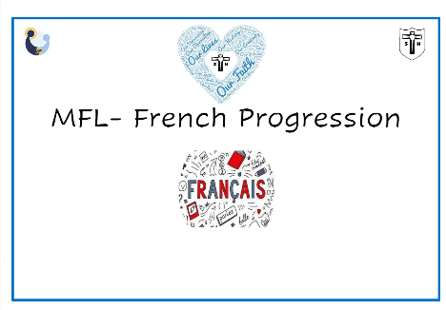

Key Stage 1 pupils will be exposed to the French language by the way of simple commands, colours, simple greetings and number.   This will be informal learning and will become part of the weekly routine.

Key Stage 2  classes will have access to a very high-quality foreign languages curriculum using the Language Angels scheme of work and resources. This will progressively develop pupil skills in foreign languages through regularly taught and well-planned weekly lessons in KS2 which will be taught by the class teacher. The chosen language of French will be taught in 30/45 minute weekly sessions. Pupils will progressively acquire, use and apply a growing bank of vocabulary, language skills and grammatical knowledge organised around age-appropriate topics and themes, building blocks of language into more complex, fluent and authentic language.

Our Progression in knowledge Map shows precisely how pupil foreign language learning across the key skills of speaking, listening, reading, writing and grammar progresses across KS2.

​

Using Language Angels as a starting point, Sacred Heart has a unit planner in place which will serve as an overall ‘teaching map’ outlining for all teachers within KS2 what each year group will be taught and when it will be taught. Each class in each year group have unit planning which specifies key questions for lessons, learning objectives and Target Knowledge of units to be taught during the academic year to ensure substantial progress and learning is achieved. Each teaching unit is divided into 5/6 lessons, except for Core Vocabulary modules, which are used as stand-alone lessons.

Every MFL Lesson

* Each unit and lesson will have clearly defined objectives and led by a key question
* Each lesson will incorporate interactive whiteboard materials to include ample speaking and listening tasks within a lesson.
* Lessons will incorporate challenge sections and desk-based activities that will be offered with levels of stretch and differentiation.
* Reading and writing activities will be offered in all units. Some extended reading and writing activities are provided so that children are appropriately challenged.
* Every unit will include a grammar concept which will increase in complexity as pupils move throughout their language learning journey.
* Extending writing activities are provided to ensure that pupils are recalling previously learnt language and, by reusing it, will be able to recall it and use it with greater ease and accuracy. These tasks will help to link units together and show that pupils are retaining and recalling the language taught with increased fluency and ease.
* Every lesson will encourage high think/ participation ratio using the Teach Like a Champion Techniques used at Sacred Heart.

​

Units are progressive within themselves as subsequent lessons within a unit build on the language and knowledge taught in previous lessons. As pupils progress though the lessons in a unit they will build their knowledge and develop the complexity of the language they use.

French is the only language, alongside English that is taught in every country of the world

Curriculum Review

The intent is that all content will be continuously updated and reviewed annually, creating a dynamic programme of study that will be clearly outlined in both long-term and short-term planning. This will ensure that the foreign language knowledge of our pupils progresses within each academic year and is extended year upon year throughout the primary phase and, in so doing, will always be relevant and in line with meeting or exceeding national DfE requirements.

Monitoring

The MFL leader and senior management are responsible for observing practice and monitoring the quality and impact of Modern Foreign Languages teaching and learning.

Monitoring throughout the school takes place whereby the subject leader:

* Updates and measures the impact of the staff expectations document for MFL ensuring it is clear and concise.
* Planning – checking for coverage of knowledge, supports teachers via discussion of our whole- school progression map to adapt and make changes if necessary.
* Book audits and Pupil voice.
* Reviews resource provision.
* Learning walks, which involve lesson observation drop ins.
* Curriculum link governor will also visit to see ‘Our Curriculum’ in action.

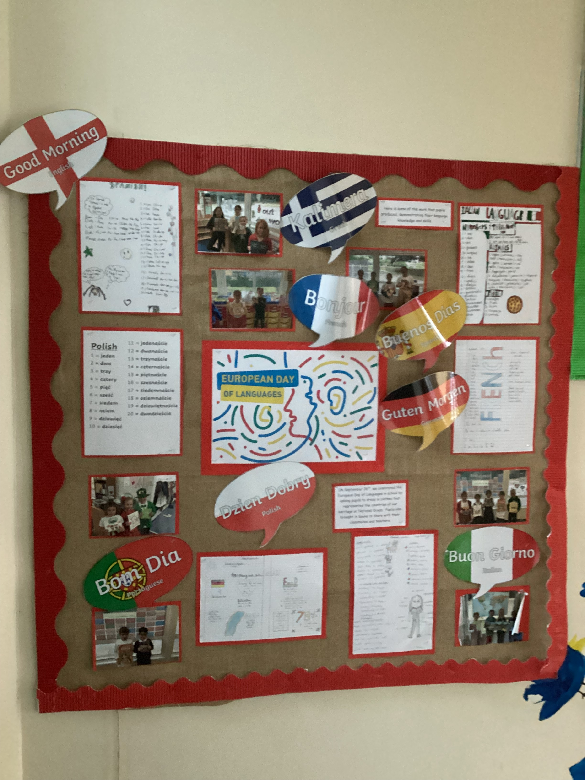

Feedback, Assessment and Reporting

Teacher’s record the progress made by children against the learning objectives for their lesson by assessing if they have achieved the Key Question, KQ by highlighting this green or orange.

Feedback is given to pupils in line with our feedback policy. This is often verbal and, in the moment, to enhance pupils’ progression. Pupils will respond to individual or whole class feedback in green pen.

Pupils will be assessed on their ability to do each of the following aspects:

​

* understand and respond to spoken and written language from a variety of authentic sources
* speak with increasing confidence, fluency and spontaneity, finding ways of communicating what they want to say, including through discussion and asking questions, and continually improving the accuracy of their pronunciation and intonation
* can write at varying length, for different purposes and audiences, using the variety of grammatical structures that they have learnt
* discover and develop an appreciation of a range of writing in the language studied

Reporting to parents – Comments regarding progression against the age-related expectations for this subject are reported to parents as part of the end of year report.

Reporting to governors – The subject lead will report to the Curriculum Governor once a year.

​

Learning another language will help me when I travel.

Year 6

Impact

We have been using Language Angels for just over an academic year. Our Curriculum has ensured all pupils develop key language learning skills, as set out by the national curriculum, as well as a love of languages and an appreciation for other cultures. By the time Year 6 pupils leave Sacred Heart, they will have acquired basic skills in the 4 key strands of language learning – speaking listening reading and writing and will have acquired a solid foundation upon which to pursue further language study.

​​

Pupils will continuously build on their previous knowledge as they progress in their foreign language learning journey through the primary phase. Previous language will be retrieved , recycled, revised, recalled and consolidated whenever possible and appropriate, creating a good foundation for their learning in KS3.

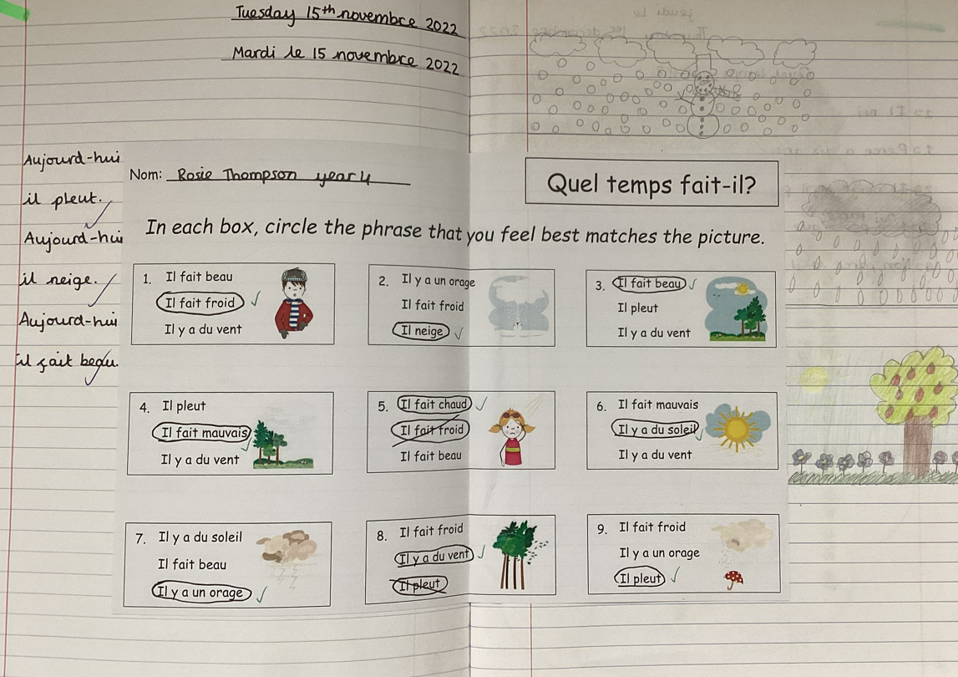

Developing MFL at home

We know many of our families speak a language other than English at home, it may be fun to learn some more French together.

If you would like to learn some more French at home you can use the following sites and Apps:

<https://www.bbc.co.uk/bitesize/subjects/z39d7ty>

<https://www.duolingo.com/>

<https://oraprdnt.uqtr.uquebec.ca/pls/public/gscw031?owa_no_site=1869>

<https://www.littleredlanguages.co.uk/>

<https://www.thefrenchexperiment.com/>

<https://readtoday.net/#appFR-1>

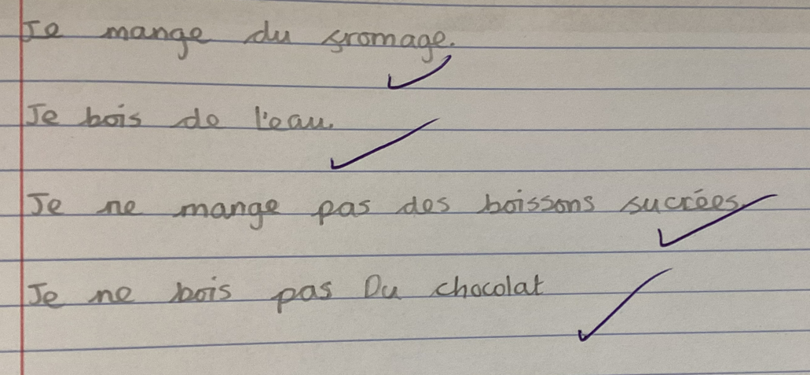

Development points for 2024- 2025

1. To ensure MFL is consistently taught and specific to our setting
2. To develop use of effective assessment

I like singing French songs and playing games.

I like learning French, I can see similarities with Polish.

My child really enjoys the French lessons and it gives them a good start for language learning in secondary school.

I like learning about different languages and cultures.

Policy written: October 2024 Written by: Miss Owens Review: September 2026