Year 6 Homework Menu – Advent 2 2023
The Amazon Rainforest
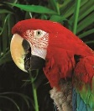  Design a new animal that could live in the Amazon Rainforest. Think about what it will eat, which part of the rainforest it will live in and what its predators might be. | Imagine you are an explorer in the Amazon Rainforest and write a diary entry/daily log.   |   Think about the sounds you might hear in the rainforest. Can you recreate them with things you have at home? Create and record a soundscape of the rainforest. | Create a climate graph of the average rainfall and temperature in the Amazon Rainforest for every month in a year.  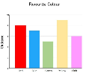
Design a rainforest outfit for tourists and add annotations to explain your choices.   | Create a map showing the location of the different rainforests around the world.   | Research a rainforest animal. Annotate a photo or illustration to describe and explain how its adaptations help it survive in the rainforest.  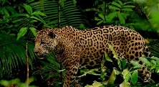 | 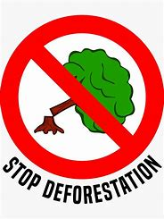  Create a poster to encourage people to stop destroying the rainforest. Make sure it’s persuasive!
Create a survival guide for explorers in the rainforest. Think about what they could eat and how they will make shelters.   |   Research biodiversity in your local area. How many different plants and animals can you find in your garden/local park/outdoor area? Use photos/drawings to present your findings. | 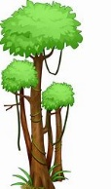  Choose your own materials to make a model of a rainforest plant. (Remember that trees are plants too!) | Use the internet to research what different companies are doing to try and combat deforestation. (Eg. Not using palm oil in their products.)  

