 | Little Wandle - Letters and Sounds  EYFS Phonics Home Learning | 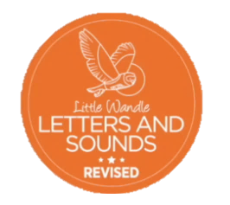
 | Phase 2 – Autumn 2 Week 3
Please support your child to practise and reinforce the phonemes and graphemes we are learning in school. More information and support can be found on the Little Wandle website - https://www.littlewandlelettersandsounds.org.uk/resources/for-parents/
Phonemes we will be focusing on this week in school –
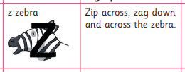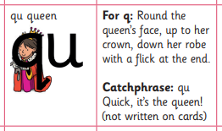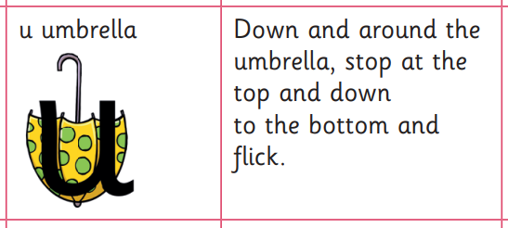

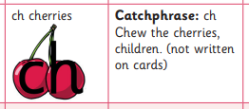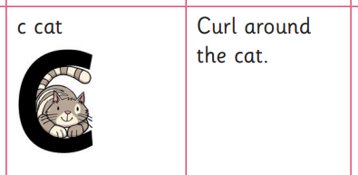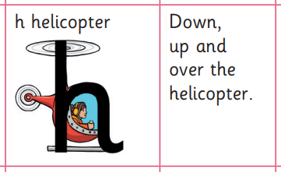

We will be reading and writing these words. Can you spot this week’s phonemes?
zip quick chip zap chop quack buzz rich quit

Can you say the rhyme as you trace over the letter?
Zip across, zag down and  across the zebra | Round the queen’s face, up  to her crown, down her robe  with a flick at the end | Down and around the umbrella, stop at the top and down to the bottom and flick

We will be practising tricky words. Can you spot the tricky part of the word?

and has his her go no to into

