Year 6 Homework Menu – Advent 2023

Cook a Victorian recipe and take a photo or bring it into school!  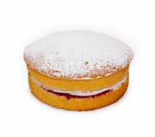 | Research William Morris and create your own artwork inspired by his designs.  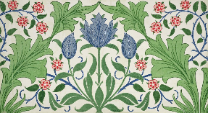 | 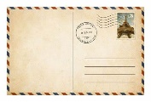  Where did the Victorians go on holiday and what did they do there? Write a postcard from a Victorian holiday. | 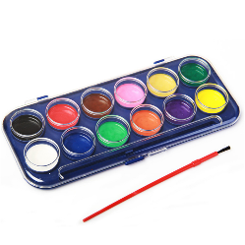  Paint or draw a Victorian scene. What does it show us about Victorian life? | 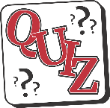  Make a Victorians quiz to test your friends and family.
What was life like in a Victorian home? Draw a picture or use a shoebox to create your own!  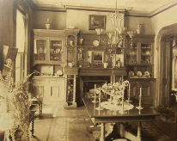 | 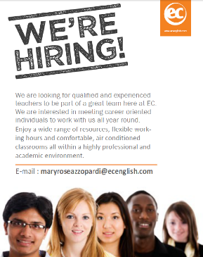  Find out about different Victorian jobs (for children or adults) and create a job advert for one of them. | Choose one homework option each week. Remember to bring it into school on Mondays. | 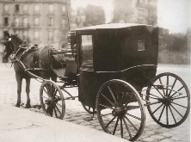  Research different types of transport used in Victorian times and compare with today. | 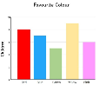  Research kings and queens of the past. Make a bar chart to compare the length of Queen Victoria’s reign with other kings and queens.
Write a newspaper article announcing Queen Victoria’s coronation.  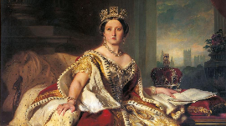 | Who was Charles Dickens? Find out about the books that he wrote.  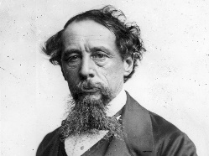 | If you were Queen Victoria, what new laws would you create and why?  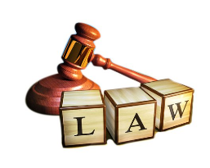 | 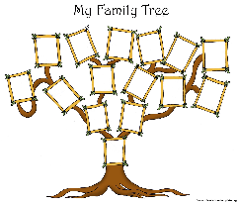  Create a family tree for Queen Victoria. | Find out about Victorian games and toys. Can you create your own Victorian game?  