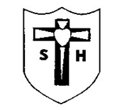

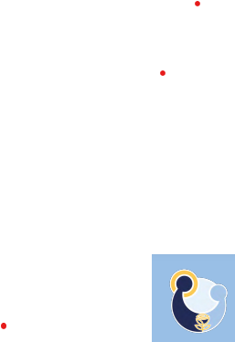

Sacred Heart Primary CVA

Southcliffe Road, Carlton, Nottingham. NG4 1EQ

[admin@sacredheart.notts.sch.uk](mailto:admin@sacredheart.notts.sch.uk) 0115 9112117

19/07/23

Dear Parents/Carers

**Year 3 Trip to the National Videogame Museum – 18/09/2023**

We are delighted to be able to offer a class trip to the National Videogame Museum on Monday 18th September 2023. We will be leaving school at approximately 10.15am and will return to school at approximately 4.30pm. Please collect your child from outside the school gates at this time.

The full cost of the trip is £26.70 and this includes activities and tour at the museum and coach travel.

Please provide your child with a packed lunch and water bottle. If you would like a packed lunch made from school, please indicate on the slip below and select your sandwich choice. Also, please indicate if you are in receipt of free school meals/pupil premium.

Please return the consent slip below by Tuesday 25th July and make payment via Arbor by Monday 31st July 2023. If you are experiencing any difficulties with this please do not hesitate to contact the school office.

Kind regards

Miss Murray

Year 3 Teacher

---------------------------------------------------------------------------------------------------------------

**Year 3 Trip to the National Videogame Museum – 18/09/2023**

I give consent for ________________________________________(Name) to attend the above event.

🞏 I will make full payment via Arbor by Monday 31st July 2023.

🞏 My child receives pupil premium/Free School Meals and I would like to receive support with this cost.

My child would like a school packed lunch with Ham / Cheese (please circle choice) Sandwich.

Signed __________________________________________________Date__________________