**The Briars**

**20th – 22nd September 2023**

The Briars is a Catholic Youth Retreat in Crich, Derbyshire, run by the Nottingham Diocesan Catholic Youth Service. We will be going for a two-night residential on Wednesday 20th September, returning on Friday 22nd September.

**Before we go:**

The children will be given a medical form that needs completing and returning to school before we go. If your child will need any medication whilst we are away, please ensure that it is on the medical form. Any medications should be clearly labelled with the child’s name and handed to Miss Armstrong on Wednesday morning.

Suitcases should be brought to school on Wednesday morning and left in the hall. We will be leaving at about 10am – you are more then welcome to come and wave us off!

Enclosed is a packing list detailing what the children need to bring with them. All bedding is provided but they will need to bring a towel. We will be going for a walk on the Thursday so please ensure the children have suitable footwear and clothing (it can be a bit muddy!) There will be a disco on the final night so they may bring disco clothes to change into if they wish.

Please don’t pack any devices (including mobile phones) or extra sweets/snacks. There will be opportunities to purchase snacks and drinks from the vending machine each day, as well as Briars merchandise, so they children can bring some pocket money (no more than £10) packed in a wallet or purse. If you would rather I look after pocket money, please give this to me on the Wednesday morning in an envelope clearly marked with the child’s name. The children may bring a camera with them if they want but I will also make sure that I take plenty of photos to share with you on Dojo!

**Wednesday morning:**

The children should come to school in their own clothes and bring a packed lunch and water bottle. On the way to the Briars, we will be stopping at Chatsworth Farm Park where we will spend most of the day. There are lots of exciting things to do at the park, as well as the opportunity to feed the animals. We will leave there at approximately 2:30 to travel to The Briars.

**Sleeping arrangements:**

Rooms are single sex and there will be a separate boys’ and girls’ corridor. There will be at least one school staff member on each corridor. The Briars have strict rules about the children not going into anyone else’s room during our stay.

The children will be told their rooms and who they will be sharing with once we arrive. I will ask them beforehand to give me a list of people they would ideally like to share a room with and will guarantee at least one person from their list. I will put them with as many people from their list as possible but it does depend on room sizes.

**Our time at The Briars:**

The children will be split into small groups by Briars staff once we arrive. They will spend part of each day in their group, taking part in lots of different activities with their group leader (a member of The Briars team).

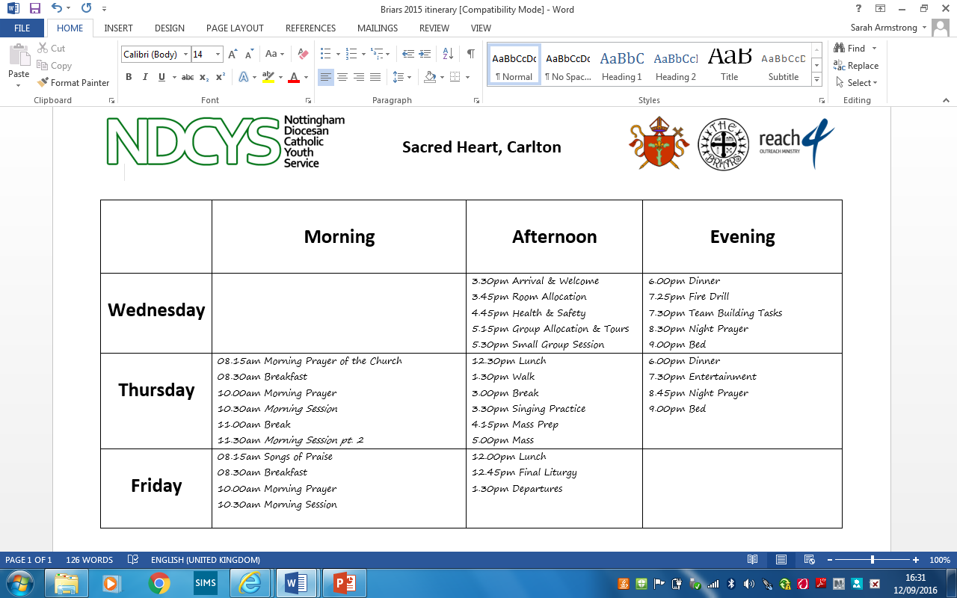Here is an example timetable to give you an idea of what we will be doing:

**Food:**

All meals will be provided (except for lunch on Wednesday – please remember to bring a packed lunch). The Briars catering team provide delicious, home-cooked meals served in their dining hall. School and Briars staff will serve the children with their food and there will be at least one adult on each table.

**Returning to school:**

We will be picked up by the coach after lunch on Friday and will return to school before the end of the school day so you can collect the children as normal.

If you would like any more information about The Briars, here is a link to their website:

[www.ndcys.com/thebriars/](http://www.ndcys.com/thebriars/)

If you have any questions about our trip, please message me on Dojo or find me on the playground at the end of the day.

I’m really looking forward to our trip and I know the children will have a truly unforgettable experience!

**Packing List**

What to bring:

Enough clothes for 3 days

Underwear and socks

Sensible footwear

Suitable clothes for a walk in the countryside (+ spare clothes for later that day in case we get wet!)

Suitable footwear for a walk in the countryside

Waterproof coat

Disco clothes

Nightwear

Towel

Toothbrush and toothpaste

Toiletries (for a wash in the morning and a shower in the evening)

Pocket money – no more than £10 (optional)

Any required medication – please fill in the attached medication form. Medication needs to be given to Miss Armstrong on the day of the trip and not packed in suitcases.

What not to bring:

No electronic devices – this includes mobile phones, iPads, iPods etc.

No sweets, chewing gum, biscuits etc. All meals will be provided and the Briars team always makes sure that no-one goes hungry! There will be chance to go to the vending machine to buy snacks and drinks during our stay.