Design and Technology  Stone Age to Iron Age Homework – Advent Term 2023  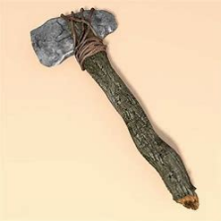  Choose an invention, land mark or shelter from the Stone Age to Iron Age timeline. Recreate this either through a diagram or a model. Label the key parts and material it is made out of. | Thinking Skills    Create an A-Z on all things Stone Age to Iron Age. Include things, places, words- anything Stone Age to Iron Age related. | Maths  Create a range of Stone Age to Iron Age themed maths problems. Can you use a range of operations?  
English  Imagine you have woken up in a Bronze Age settlement. Write a description of the setting around you, include all five of your senses. | Book worm  Find a book that is set in the Stone Age to Iron Age era. Curl up with a family member (or alone) and enjoy the book. | Get Creative  Find out about the types of clothing people would wear in the Bronze Age and create your own  outfit with labels.
Research    Carry out some research into our topic on the Stone Age to Iron Age. You could choose a particular theme. Present your findings in a way you could present it to the class. | Art  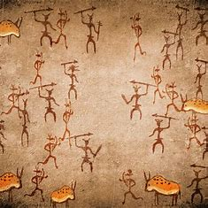  We know that the first recordings were Cave Art. Design a piece of cave art using materials of your choice. | 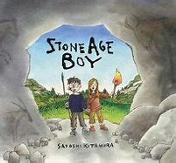  Story Time  Write you own story based in the Stone age era. Including a description of where you are and who you meet.
Geography  Find out where the best places to build Iron Age settlements were and why. | Science  Learn about prehistoric animals and their food chains. Record these on a poster, booklet or leaflet. | Get Active  Imagine you are in the Stone age, you now have to hunt and gather for your food. Go outside, into a safe open space and practice your hunting skills. Find, stalk and aim for your prey, you may want to use twigs to practice your spear throwing skills.

